Game Design Document

Fill up the Following document

1. Write the title of your project.

Unicorn Run

1. What is the goal of the game?

The goal of the game is to run from dinosaur and eat as many appls you can.

1. Write a brief story of your game?

Once the unicorn by mistake went to place were he was forbidden to go by his parents. He encounters a dinosaur and as loud as he could. The dinosaur chases him and the unicorn run to save his life.

1. Which are the playing characters of this game?

* Playing characters are the ones which respond to the user based on the input from the user
* Cars, monkeys, dinos, wizards etc, are the playing characters in the game.

|  |  |  |
| --- | --- | --- |
| Number | Character Name | What can this character do? |
| 1 | Dinosaur | It can eat the unicorn. |
| 2 | Unicorn | It can jump to save his life. It can gain enormous points for you. |
| 3 |  |  |
| 4 |  |  |
| 5 |  |  |
| 6 |  |  |
| 7 |  |  |
| 8 |  |  |

1. Which are the Non Playing Characters of this game?

* Non Playing characters are the ones which don't have an action or a behaviour when the user interacts with the game.
* Hurdles, stones, bananas, coins, etc are non playing characters in the game.

|  |  |  |
| --- | --- | --- |
| Number | Character Name | What can this character do? |
| 1 | Stone | It is an obstacle for unicorn. |
| 2 | Apple | It is helps to gain enormous points. |
| 3 |  |  |
| 4 |  |  |
| 5 |  |  |
| 6 |  |  |
| 7 |  |  |
| 8 |  |  |

Draw your imagination of this game. What does this game look like?

* Draw the game either on your computer or on paper,
* Add images of scenes of the game to show each of the playing and non-playing characters at least once.

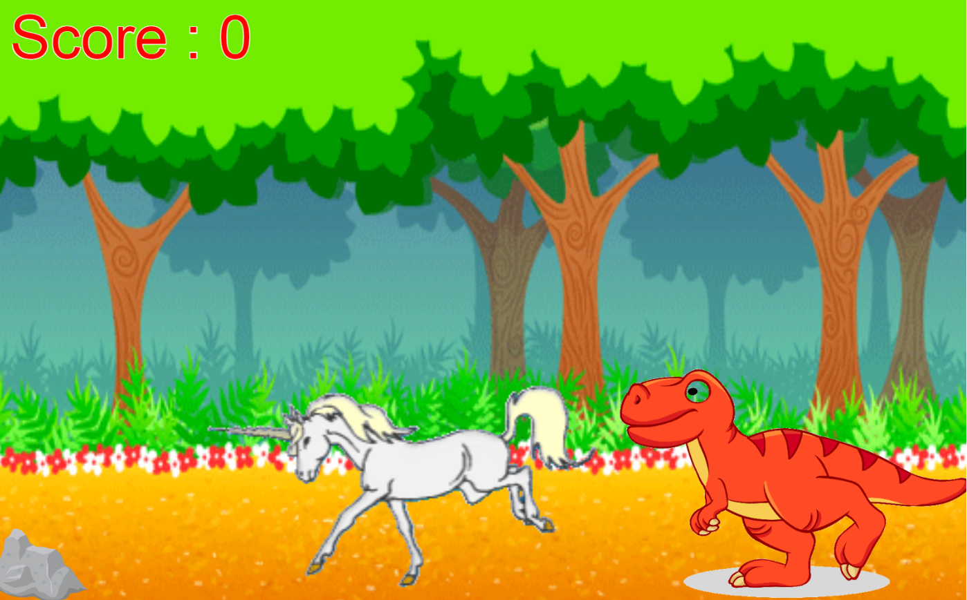

How do you plan to make your game engaging?

I am planning to make a infinite game, so it is engaging for the player.